Quick Operation Instuctions

To Simplify your business

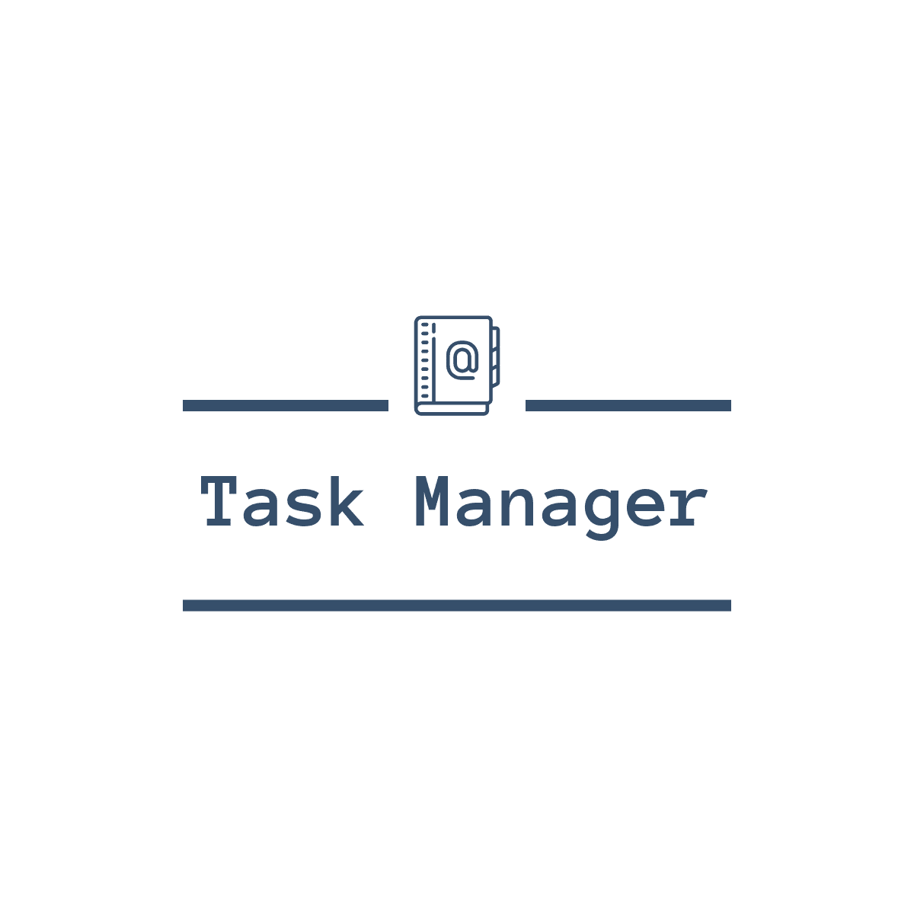

© 2020 Hendra Maulidan . All Rights Reserved .

1. Outlook & Interface

First Page :

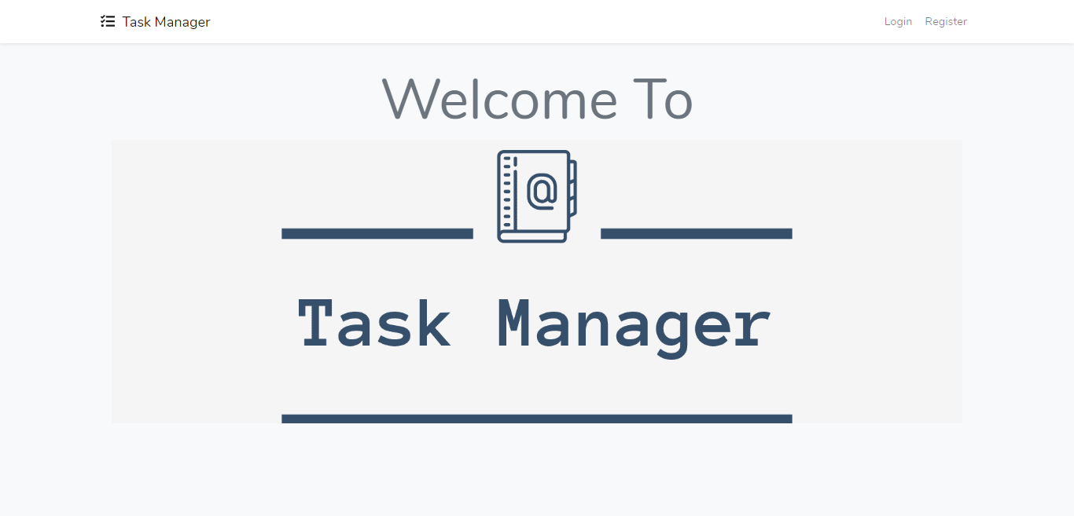

1. Register

You can register to make a new account for this web apps . You must insert with correct data .

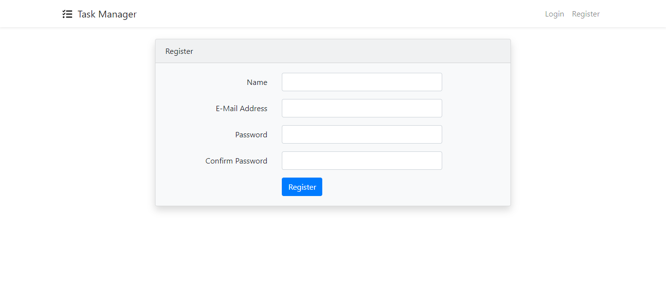

1. Login Form

If you already have an account you can login with click login button . And then Insert with data that you registered earlier .

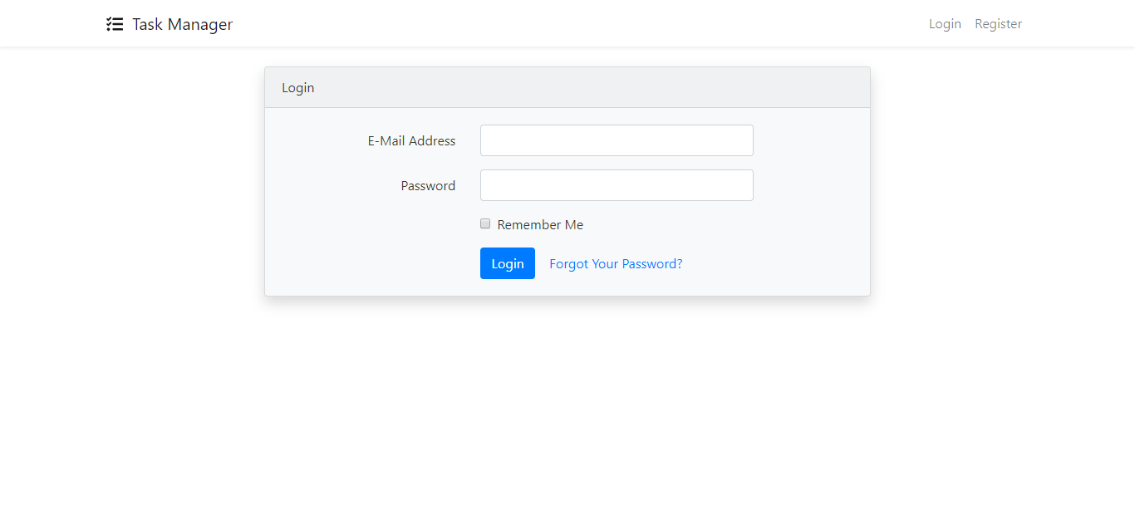

1. Home Page

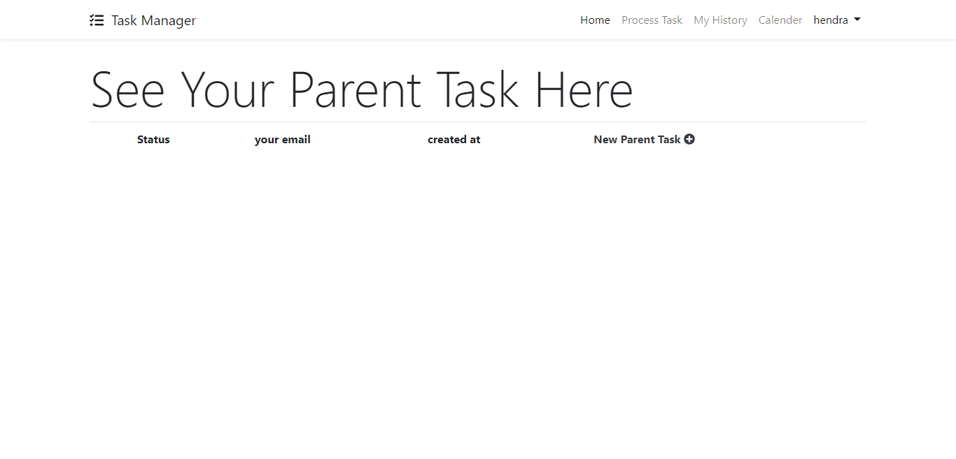

In here you can make a new Parent task with click the “New Parent Task + ” text .

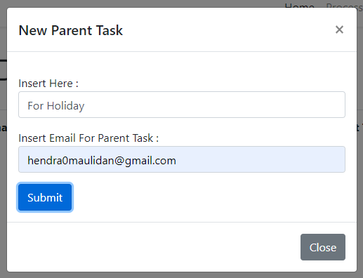

And then you can submit your parent task , and make a task in the next page with click blue Button . Or you can delete the Parent Task and edit the parent Task with click the button bellow.



1. Next Page from Parent Task

In Here you can make a new task for your parent task before with click the “New Task”. And insert your task here with everything you want .

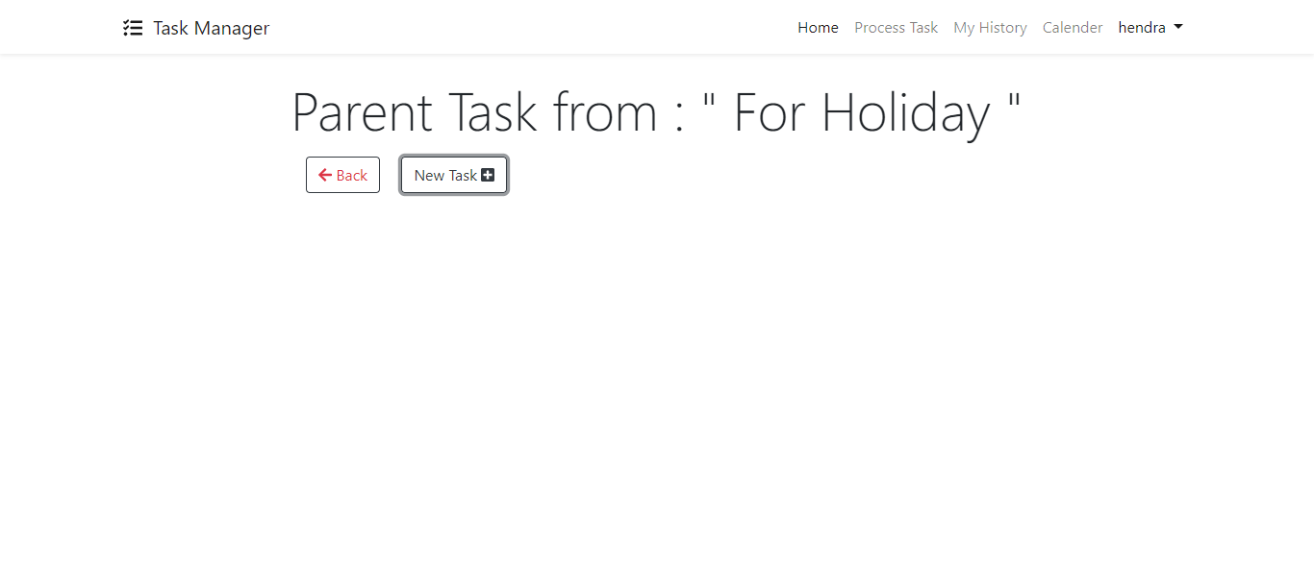

Insert task here :

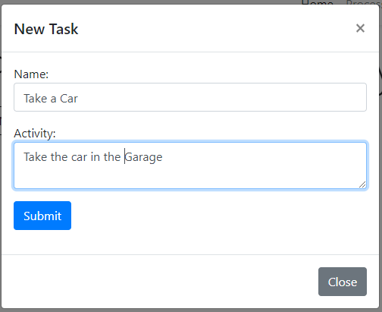

And will show like this :

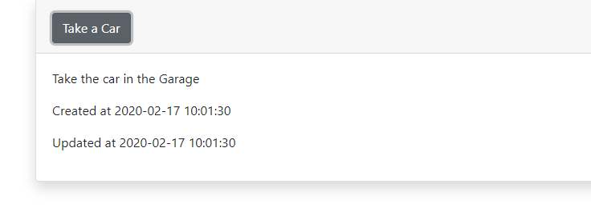

1. Process Task

In process task you can make a tasks that can tell you that you will start or process or finish the tasks .

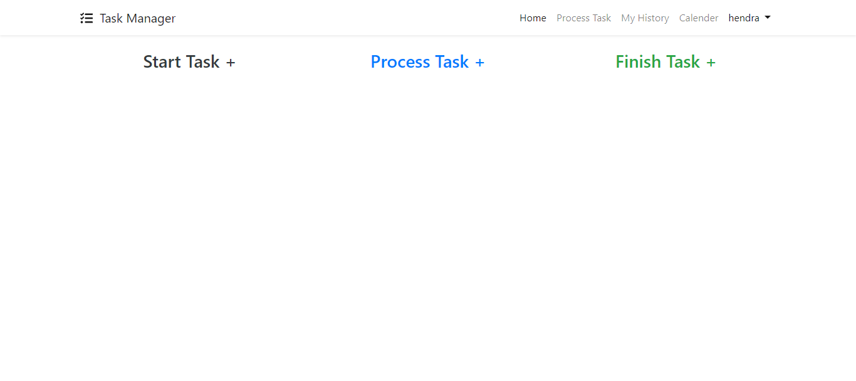 You can click “Start Task” for make a new task , or click “Process Task” for make process task

or click “Finish Task” for make Finish Task, and make task like you want .

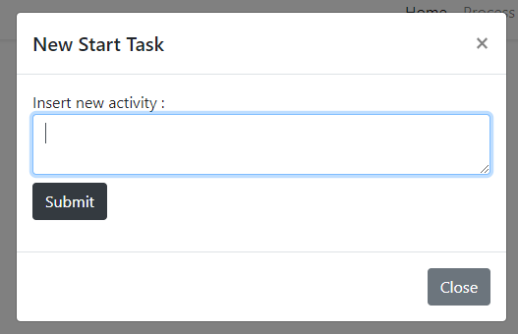

And will show like this :

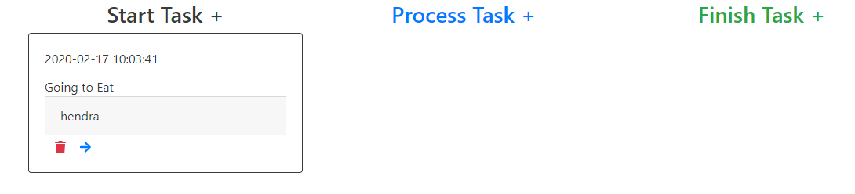

If you click next blue button you will process your task , and will show like this :

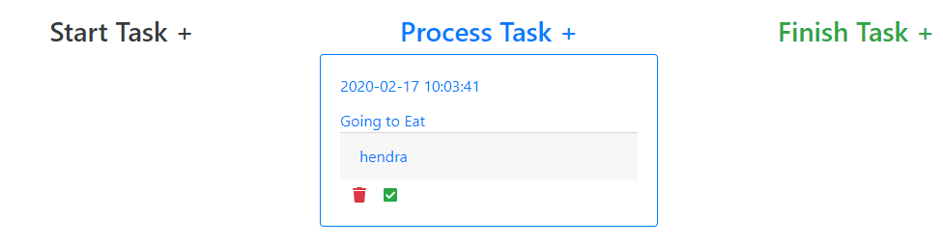

And you can end your task :

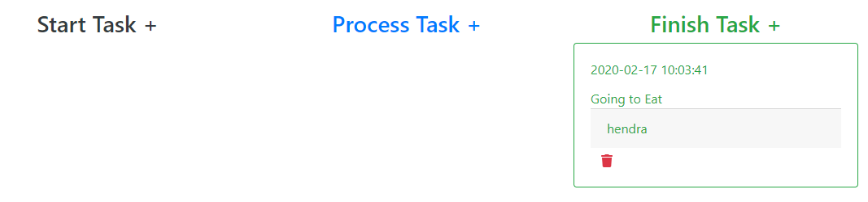

And also you can delete your task with click trash button .

1. History Page :

In here you can look your task history and of course you can delete it .

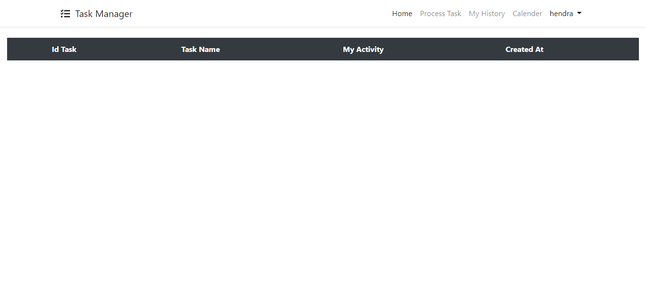

1. Calendar :

In here you can see calendar , so you don’t need to open another program for view the calendar .

